SeenPay

*seen it, then pay*



Founded at

University of New Hampshire

March, 2015

**-----------------------------------------------------------------------------------------------------------**

Executive Team: Huy Le, Jimmy Vo, Cheryl Fong, Sam Warach, Anh Nguyen, Quan H., Linh Nguyen, Zen Nguyen, Phuc Le

Advisor: Andrew Earle, Robert Tischer, Tuan Mau Le, Michelle Le, Hai Nguyen



**Table of Contents**

1. **Executive Summary………………………………………………………3**
2. **Company Overview…………………………………………………….3-7**
3. Business Structure
4. Mission
5. Vision
6. Values
7. Features
8. Our Unique
9. Business Model
10. Business Summary
11. **Business Environment……………………………………………..….7-10**
12. Overview of targeted market & customer behavior
13. Ideal Customer
14. Targeted Market
15. Potential Market Statistics
16. **Company Description………………………………………………..11-12**
17. Executive Team
18. Advisors
19. Plan for growth
20. **Marketing Plan & Strategy……………………………………...........N/A**
21. **Finance & Budget Plan** (source of income) **…………………………...…12-13**
22. **Technology** (Detail of Technology Development is in SDLC.docx)…**…………….13-16**
23. **Research & Development………………….……………………...….…17**
24. **Action Plan…………………………………………..……………….17-22**
25. 30 days
26. 60 days
27. 90 days
28. **Approximated Fund Usage……………………………..……...……23-24**
29. **Executive Summary:**

Southeast Asia (SEA) is set for an e-commerce boom, a region of great untapped potential. Sources indicate that the region’s underdeveloped e-commerce infrastructure and logistical services pose as an impediment. These are just some of the masked potential - an area of much needed improvement constituting as an opportunity for anyone who is truly determined to seize it.

SeenPay is that determined group of people, aiming to improve the online trading in Southeast Asia by creating an escrow payment solution and logistical services. We will constantly seek to innovate features to enhance these.

Consumer behavior in SEA shows that, hands on inspection of the product is the main determining factor before making the decision to buy. Mainly due to the lack of trust between the seller and the buyer. SeenPay resolves this by placing the money as an escrow between the two parties. We provide assurance to the seller for payment, and the buyer for desired product.

The process is simple, we hold the money when the buyer requests a transaction with the seller. Once a satisfied buyer has seen it, the money is then deposited to the seller after confirmation. If for any reason the buyer is not satisfied, the product is returned to seller and the money goes back to the buyer. Simulating the quintessential sensation of shopping in a physical store, making us different.

In short, SeenPay is the ideal for online trade and payments. A resourceful tool for individuals and business. We instill online consumer confidence, revolutionizing the cash dominant consumer mindset in SEA.

1. **Company Overview:**
2. **Business Structure:**Limited Liability Company (LLC), International Business.
3. **Vision:**SeenPay aim to be the top payment solution and logistic services for E-Commerce in the Southeast Asia market. We evolving the way people in Southeast Asia doing e-commerce - shop, sale, pay and ship by providing payment system and logistic services.
4. **Mission:**   
   SeenPay’s mission is to help everyone doing e-commerce securely, easily and conveniently from providing payment solution to logistic services.
5. **Our Values**:  
   Our values serve as the compass for SeenPay to be sustainable in the long run.

|  |  |
| --- | --- |
| Safe & Secured | Security is always our top value. As a payment system, protecting our customer’s information and assets is our mission |
| Customers | We would like to treat our customers as the king. We build strong relationships and deliver value to our customers |
| Partnership | We build trusted communities, collaborative and work like a connected network |
| Sustainability | Our people understand the bigger picture, keep innovating, building and developing |
| Integrity | Integrity is one of the most important value that we would like all of our employees must have |

1. **Services/Features:**
2. Hold - Check and Release/Return system (escrow payment service)
3. Pick – Pack – Ship – Track (logistic services)
4. Cross-border goods trading and money transfer
5. User account review (Seller stats)
6. Customized framework policy / contract between seller and buyer
7. SeenPay wallet – smart electronic wallet to store money for payments including Pre-paid card Gift card / voucher
8. Dialog/Chat between buyer and seller when processing payment and tracking item SeenPay general policy protecting sellers and buyers
9. Pay bill online (utilities, cables, etc1)
10. **Our Unique System:**
11. **Hold – Check – Release/Return (Escrow concept):** The escrow service concept is not new, especially in finance and mortgage payment in the U.S. However, this concept can be applied in Asia/Southeast Asia (SEA) e-commerce market to solve the problem of e-commerce in Asia/SEA. In Southeast Asia countries, people do not shopping online oftenly like in the U.S because they don’t trust the online people/users, and they don’t trust the Internet, according a lot of researches/surveys/reports. The escrow payment service for online retail is a must have to encourage people to shop more online and become their life-style just like in America.

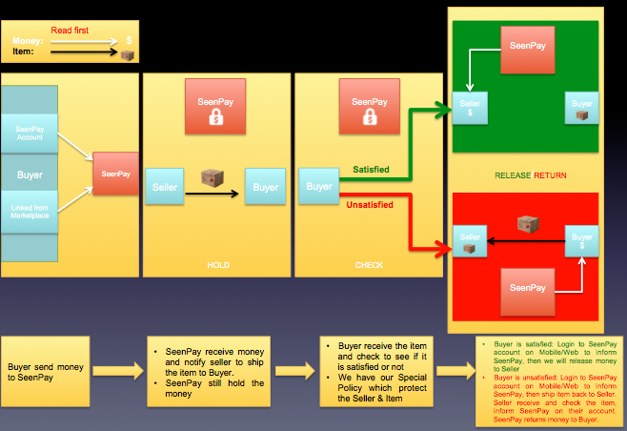

* Step 1: Buyers choose the item they want to buy, request transaction through SeenPay and send money to us.
* Step 2: SeenPay will notify the sellers to ship the item, but do not release the money to the seller yet.
* Step 3: The buyer receives the item from the seller and checks it.
* If the item is as good as the description of the seller, the buyer will notify SeenPay to release the money to the Seller, transaction success.
* If the item is not as good as the description of the seller, the buyer will notify SeenPay to return the item to the seller, SeenPay will return the money to the buyer.

Note:

SeenPay has our General Policy which covers the limited time of returned item and condition of item to protect both parties.

1. **Pick – Pack – Ship – Track:** Due to the problem that the logistical services in Southeast Asia is really bad and that is the reason which against the growth of e-commerce in the area, SeenPay will offer a logistical “in area” delivery system which help a lot of e-commerce marketplace which using traditional logistical service like DHL, UPSA, Country’s Post Office. According to our research about Infrastructure and Logistics in Southeast Asia, most of the delivery company in the Area doesn’t offer tracking number, and the risk of damage/lost product is higher than other area in the World. Another opportunity for us to offer logistical services is because of the labor in Southeast Asia, especially in Vietnam is really cheap. However, this is a really long-term plan, we need a lot of more market research and data to do this concept.

* **Strength:** Cheap labor and warehouse rental fee.
* **Weaknesses:** Human resources and employee training
* **Opportunity:** None of the delivery service in our targeted market has tracking number. Consumers don’t trust and don’t use delivery service oftenly because the high risk of lost/stolen and damage.
* **Threat:** Competitors from traditional delivery services will offer the same idea because the market is more competitive.

Pickup the product from user’s request

Ship it through Air-delivery, Train-delivery or Bus-delivery partners of SeenPay if it is far distance

Pack it and give user online tracking number

1. **Business Structure:** SeenPay is a startup business, and we offer services. We are developing our business structure adaptively everyday to be sustainable. There are 3 most important teams currently are Technology, Business and R&D under SeenPay’s executive board and Founder/CEO.
2. Executive Board: Executive Board is included the Founder/CEO and the rest of they key people who has been working in our team since we was a concept. The Executive Board is the group of people who make final decision for the entire company.
3. Business Team: The business team is the spirit of our system, the team is included Marketing and Finance.
4. Technology Team: The place where all the engineers and developers working together.
5. Research & Development: R&D team is the top important in our system. The researchers in different fields of study like technology & business working together like a compass to guide the company to the right direction.

Executive Board & Founder/CEO

Technology Team

Business

Team

Research & Development

Marketing

Finance

Web

Mobile

Internal

System

Service Development & Testing

Banking Security

Market Data

1. **Business Model Summary**

**Business Opportunities/Plan to seize**

**Possible Opportunities**

* The needs of payment solution which offer escrow service in Asia to create the trust for the Internet users
* The needs of a better logistical services is the must improved services in Asia
* 2015 Vietnam's population hit 92 million with 39 percent using Internet, and 58 percent of the Internet users shopping online.
* In Vietnam online purchasing of each person a year was estimated at about 145 USD, and B2C sales revenues reached 2.97 billion USD.
* Online payment market in Vietnam have more than 6 million users, value 19 million USD, and will grow in future.

**Potential Threats**

* Connections and relationship
* All B2C marketplaces need escrow payment to exist
* Consumers don’t trust online trading

1. **Business Environment:**
2. **Overview of Targeted Market & Customer’s Behavior:**

* E-Commerce in Asia/SEA is really new and growing fast everyday.
* E-Commerce in the U.S a developed online market and experienced online shoppers.
* Consumer’s behavior of Asian shoppers and American shoppers is different because of the different in Culture. The consumer’s behavior including the trust between buyer and seller, the credit of the traders, the product quality, and the way people expect what they will get from shopping online. All of those are different if compare Asian shoppers to American shoppers.
* The infrastructure and logistics of commerce in Asia is not as good as the U.S. In Asia, the infrastructure of Commerce is too bad so E-Commerce will be the main course. Mailing system is a great example.
* The product’s quality, the variety of different products offered from unknown sellers in Asia is also a factor which makes Asian shoppers don’t trust online shopping.
* The security and fraud issues of the internet and website in Asia is not in the same level with the internet system in America.
* The Government of Countries in Asia does not has the ability to take full control of the internet and E-Commerce business.
* Asian shoppers prefer hands on inspection, physical touching and trying the product before they release the money.
* The internet users and usage in Asia is growing really fast but still can’t compare to the U.S
* Shoppers feel hesitation to do online shopping due to the lack of knowledge and experience on e-commerce.
* The trust of consumers on online shopping or e-retailers is very tenuous.
* Cash on Delivery is dominate payment method in Asia.

1. **Ideal customer:**

* Age and education level:

|  |  |  |
| --- | --- | --- |
| Ranking | Age | Occupation |
| 1 | 17-35 years old | Students, junior workers |
| 2 | 36-55 years old | Senior workers |
| 3 | 55-65 years old | Retire |

* Geographic:

|  |  |  |
| --- | --- | --- |
| Ranking | Living Area | Living Condition |
| 1 | Urban | Big City |
| 2 | Urban | Medium City |
| 3 | Urban | Small City/Countryside/Province |

|  |  |  |  |
| --- | --- | --- | --- |
| Cross-border Targeted Countries Ranking | | | |
| Ranking | Trade between Countries | Combined population  (Million) | Combined E-Commerce  Market Value  (USD) |
| 1 | Vietnam – Thailand | 159.04 | $5.5 billion (2.9 + 2.6) |
| 2 | Vietnam – Singapore | 96.4 | $6.35 billion (2.9 + 3.45) |
| 3 | Vietnam – Cambodia | 106.14 | $3.9 billion (2.9 + 1) |
| 4 | Vietnam – Laos | 97.77 | $3.8 billion (2.9 + 0.9) |

1. **Target Market (E-Commerce):** Southeast Asia C2C, B2C & C2C Market

* Current Target: Vietnam (Ho Chi Minh City, Hanoi, Da Nang)
* Top Targeted Cities: Ho Chi Minh City, Hanoi, Phnom Penh, Bangkok and Singapore.

|  |  |  |  |
| --- | --- | --- | --- |
| Short to Long-term Targeted Cities Ranking | | | |
| Target Ranking  (Short – Long term) | City | Country | Population (million) |
| 1 | Ho Chi Minh City | Vietnam | 12.87 |
| 2 | Hanoi | Vietnam | 7.067 |
| 3 | Singapore | Singapore | 5.399 |
| 4 | Phnom Penh | Cambodia | 1.052 |
| 5 | Bangkok | Thailand | 6.355 |
| 6 | Yangon | Myanmar | 2.513 |
| 7 | Kuala Lumpur | Malaysia | 1.589 |
| 8 | Jakarta | Indonesia | 9.608 |
| 9 | Da Nang | Vietnam | 1.020 |

1. **Potential Target Market Statistics:**
2. **Vietnam E-Commerce – a largely untapped opportunity:**According to PWC report about Southeast Asia in 2014, Vietnam retail market is reaching 91 million aspiring consumers with strongly growing incomes when the retail market is highly fragmented and quality retail space is rare and expensive. More and more people believe that e-commerce could be the answer. PwC has conducted extensive research to find out how big the Vietnamese e-commerce market will be, what the most popular business models are and which specific challenges and opportunities companies need to understand when they build their e-commerce strategy.
3. **There is no clear e-commerce market leader yet:**Vietnam’s e-commerce sector is very fragmented and there are no clear market leaders in both the Consumer-to- Consumer (C2C) and Business-to- Consumer (B2C) e-commerce markets. The most popular business model in the Vietnamese e-commerce industry is market places. Notable players in this segment are local companies such as Vatgia.com, enbac.vn, 5giay.vn. Prominent e-tailers include solo.vn, yes24.vn and zalora.vn. Thegioididong.com, dienmay.com and nguyenkim.com, the online channel of Vietnam’s leading specialist retailers are also very popular. However none of the players appears to have reached a market share of more than 5%. Newcomers who act quickly thus still have a fair chance to establish themselves as strong players in a relatively untapped market.
4. **E-Commerce market value:** $2.97 billion in 2015, the second largest market in Southeast Asia after Indonesia but Vietnam has the fastest growth in the area.
5. **Population of Vietnam:** 91 million people
6. **Vietnam Internet Usage of 2014:** Vietnam internet usage is growing really fast everyday, especially Social Media network so there is a high chance of success for inbound marketing

1. **Company Description**

**1. Executive Team:**

**Founder/Project Leader: Huy Le**

School: University of New Hampshire

Major: Dual Major in Information Technology (CEPS) & Finance (Paul)

Class of 2017

Experiences:

Web Developer Internship at Weather Analytics (A startup of MIT)

Previous Finance Researcher & Internship loanvi.com/mymoney.vn (The top finance startup of Vietnam)

LinkedIn: <https://www.linkedin.com/in/huylefinance>

**IT Team Leader/Co-founder: Zen Le**

School: University of Western Sydney

Major: System Engineer

Class of 2017

Experiences:

Web Developer at zoha.vn

App Developer at Appstore.vn

IT Specialist at APPOTA AUS.

LinkedIn: <https://www.linkedin.com/in/zenle>

**Database Manager/Co-founder: Jimmy Vo**

Currently EMC Corporation Tech Support Engineer

Previous: DELL APN Software service contractor

LinkedIn: <https://www.linkedin.com/pub/thinh-vo/4b/b01/250>

**Web & Security: Phuc Le**

University of Washington

Major: Information Technology

Class of 2018

**Finance & Payment Manager: Linh Nguyen**

University of Leicester (UK)

Major: Finance

Class of 2016

<https://www.facebook.com/linh.emi/about>

**Business Developer/IT Manager: Cheryl Fong**

School: University of New Hampshire

Major: Computer Science (CEPS)

Class of 2017

**Finance/Business Analyst: Sam Warach**

School: University of New Hampshire

Major: Finance & Entrepreneur (Paul)

Class of 2017

**Graphic Design: Quan Nguyen**

School: Bunker Hill Community College

Major: Graphic Design

Class of 2018

**Marketing/Business Researcher: Anh Nguyen**

School: University of New Hampshire

Major: Marketing & Entrepreneur (Paul)

Class of 2017

**Marketing/Data Analyst: Amanda Ghattas**

School: University of New Hampshire

Major: Marketing (Paul)

Class of 2017

**2. Advisor:**

* Economics Professor - Robert Tischer, UNH Paul College
* Entrepreneur Advisor – Andrew Earle, UNH Paul College
* Project Advisor – Tuan Mau Le, MIT PhD Candidate
  + <https://www.linkedin.com/pub/tuan-le-mau/25/a25/4>
* Project Advisor – Hai Nguyen, Founder of Startup.vn
  + <https://www.linkedin.com/in/roynguyen>

**3. Plans for growth:**

**Short Term Plan** (to be updated):

* + - Developing Marketing Plan
    - Developing SeenPay Policy
    - Developing Budget Plan
    - Developing Transaction Fee formulas
    - Applying for seed funds
    - Applying Capital Venture & Startup Competitions
    - Expanding team
    - Developing business plan
    - Making IT system
    - Collecting important data
    - Creating connection and reaching out to Banks in the targeted Market
    - Launch SeenPay Escrow Payment System Beta Website on 2016
    - Debugging and developing Beta Website on 2016
    - Launch SeenPay Escrow Payment System Website on 2017
    - Persuading marketplace in Southeast Asia to use our service

**Long Term Plan** (to be updated):

* SeenPay Logistic Service
* SeenPay item center
* Customer Service
* SeenPay Server
* C2C Marketplace for trading across Southeast Asia modeling Taobao of China
* B2B Cross-border escrow payment service
* Cross-border transfer

1. **Marketing Plan** (to be updated, need more research):
2. **Financial Plan** (to be updated, need more research):

Seller: The account which receiving money

Buyer: The account which sending money

**The basic how we generate money just like other payment services:**

1. The main source of income is from transaction fee by providing payment services. The transaction fee when using our payment service either from the online Marketplace or on our website. However, there will be a threshold for users to use the service for free without fixed transaction fee.
2. Fixed Transaction Fee: this fee is applied for each transaction regardless the amount of money
3. Variable Transaction Fee: this fee goes up if the amount of money received by the seller goes up.
4. The second source of income is from contracting merchants, pre-paid & top-up mobile cards
5. **Technology:**

Technology is the most important part of this system. We have a separate plan of development of Technology from our IT Team called SDLC (System Development Life Cycle).

**Current Mission:**

* Complete Interaction Diagram between B2C & C2C using Lucid Chart
* Complete Network Hardware planning
* Complete Network Topology using Diagram or Cisco Packet Tracer
* Complete Network Topology configuration in Cisco Packet Tracer

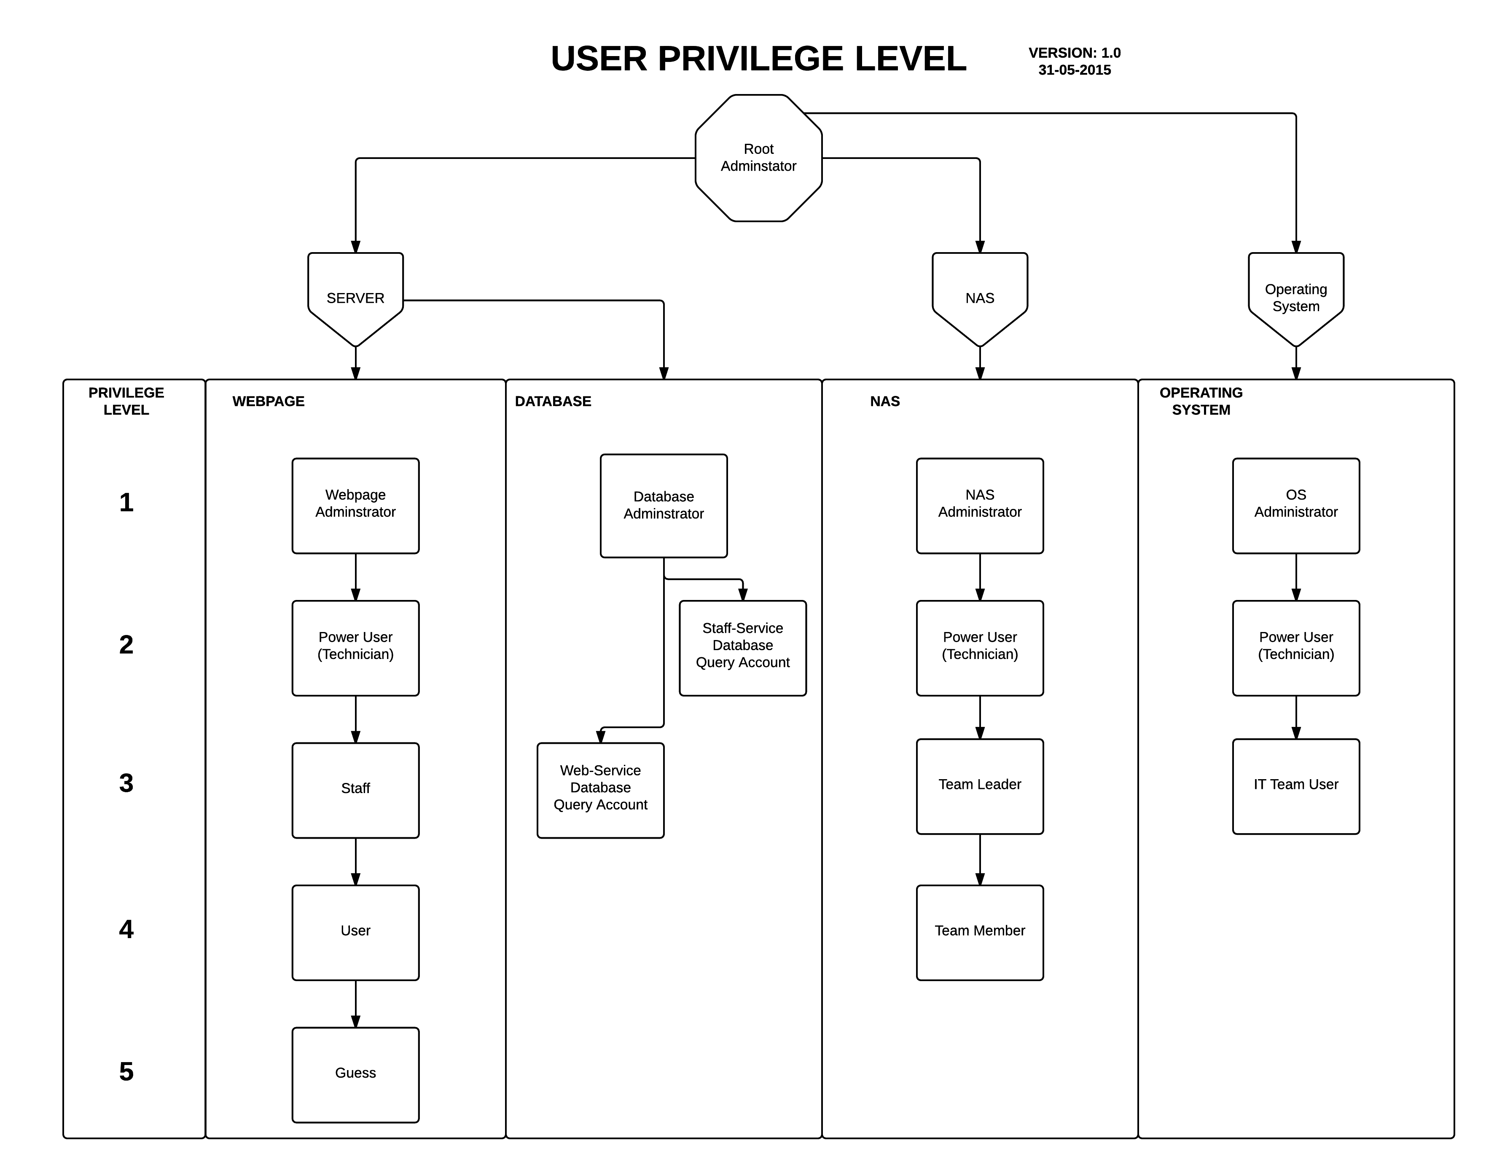

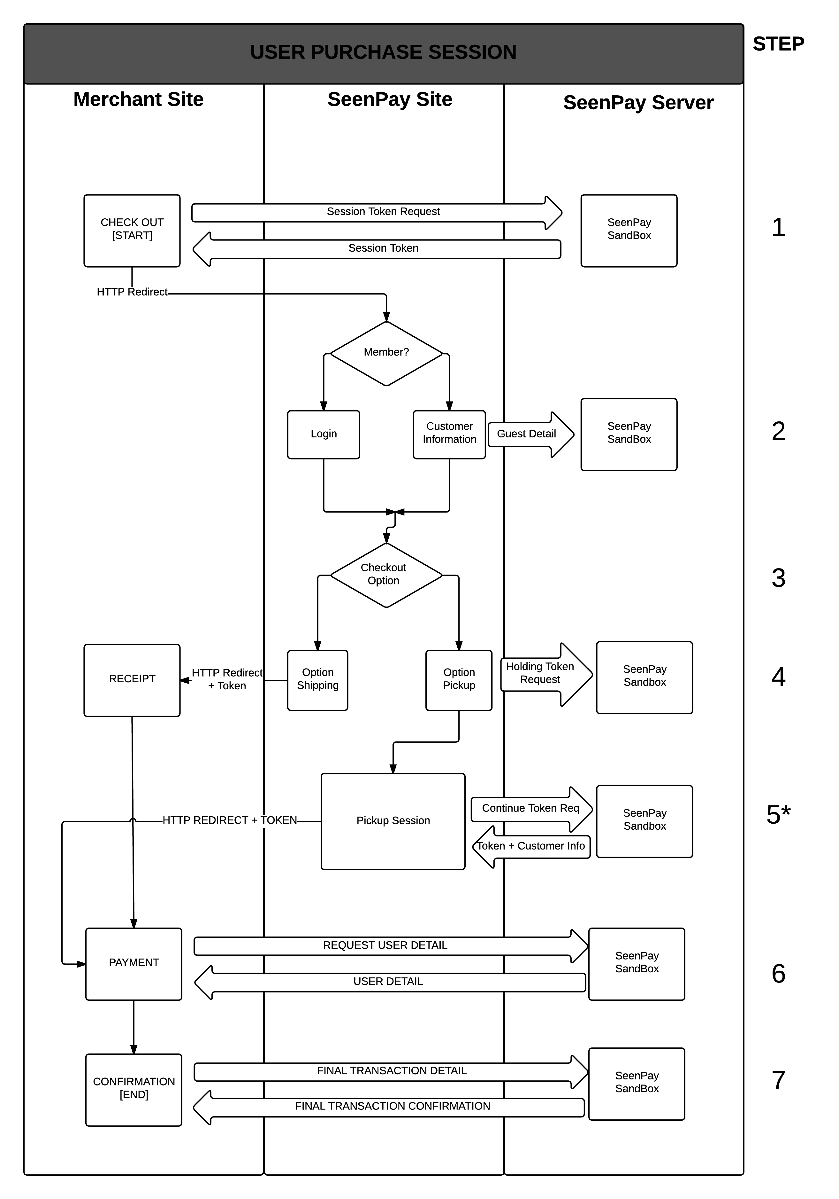

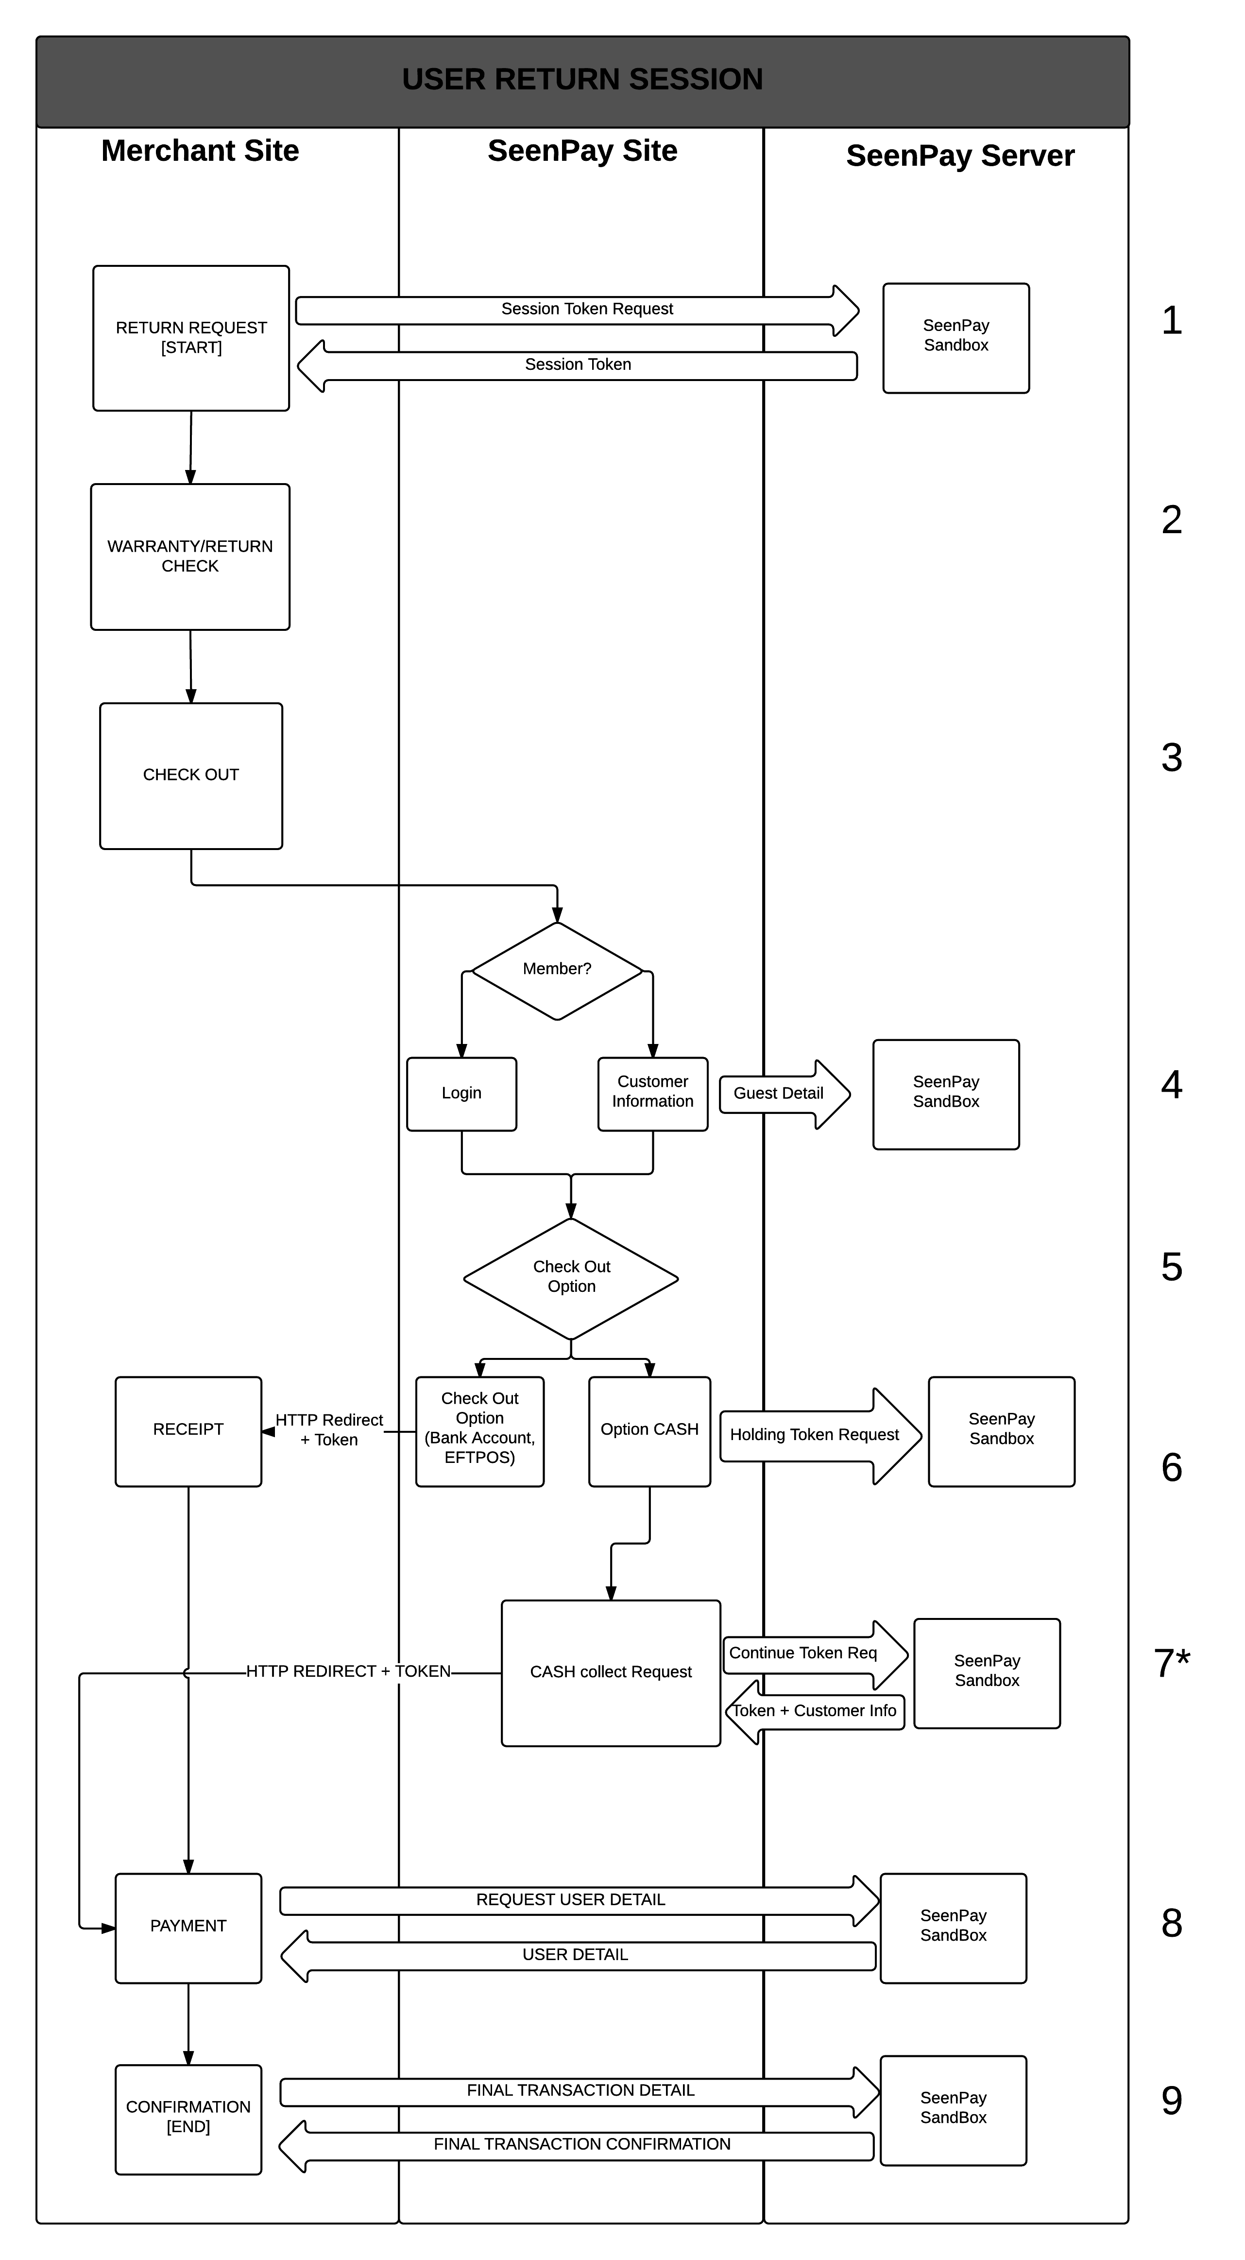

1. **Research & Development**

*The ability to design and develop new services and improves current services/technology*

1. Market Research
   1. Competition Researching
   2. Researching current target market:
      1. Consumer’s behavior
      2. Sending out survey about third-party payment solution
      3. Collecting data from surveys and analyze those
      4. Business Law at the place of the target market
      5. The key people, connection our company should reach out
2. Technology Research
3. Marketing & Social Media research
4. Consumer Behavior Research
5. Internal Research & Feedback
6. **Action Plan (Milestone)**

|  |
| --- |
| 30 Day Plan |
| |  | | --- | | WEEK 1   * Research on optimizing the best features to offer. * Research on improving business plan. * Research more on the competition. * Learn and understand the flaws and weaknesses of the competition. * Consult with an IP Lawyer if necessary. * Learn more about licensing and agreements. * Formulate with a better team structure. * Continue to recruit skilled members  ( throughout whole process ). * Search for professional guidance/Long term Mentorship ( throughout whole process ). * Continue to research the market and understand the consumer behavior in Vietnam. * Understand and recognize the long term goals. | | WEEK 2   * Purchase the server. * Purchase the web domain. * Consult with IT team. * Prepare social media for SeenPay branding. * Establish a group in charge of this. * Perfecting the payment process. * Come up with a terms and conditions policy. * Research on latest payment solution technology. * Research on the best method to persuade consumers in Vietnam that it’s better than carrying cash all the time. | | WEEK 3   * Work on payment security prototype. * Learn more about online frauds. * Find a way to always get updates on Malware and ways to breach security. * Learn about latest security threats. * Continue with terms and conditions policy. * Learn on connecting bank features onto user accounts or find someone who knows how. | | Week 4   * Purchase the web domain. * Continue week 3’s work. * Create a user friendly website. * Work with graphics team. * Finish up work from previous weeks. * Adjust next 2 months’ plan schedule. * Consult with mentor(s) about SeenPay’s whole week development. * Make a rough schedule after 90 days. | |

|  |
| --- |
| 60 Day Plan |
| |  | | --- | | WEEK 5   * Continue with securing the payment process. * Continue with website construction. * Continue to develop the platform. * Testing the platform within the team. * Find someone good at Google Analytics. * Form an IT statistics analysis team. * Try to hack into the payment system and learn about system’s loopholes. | | WEEK 6   * Promote SeenPay through social media and use advertisements. * Launch SeenPay website. * Test out payment process (prototype) with people who never. * Find more people to use (e.g. Vietnam users or students) to try to use prototype and give feedback. * Learn about and apply Search Engine Optimization (SEO) to gain more recognition. * Research on finding venture capitals, and find out  more on qualities that investors look for. * Find ways to persuade IGD Ventures Vietnam and Cyberagent Ventures. * Continue to monitor analytics (e.g. website ). * Make sure all necessary features are up and running. | | WEEK 7   * Gather feedback from website based on user visits and analytics. * Gather feedback from candidates that use the payment system. * Analyze all feedback. * Conduct surveys online (especially Vietnam recipients). | | WEEK 8   * Continue with making the payment system run smoothly, find bugs and try to hack into system. * Continue to monitor analytics ( e.g. website visits ) * Find people in Vietnam who are willing to establish a base for product checking. * Form a customer service system and learn more about dealing with customers * Adjust next 2 month’s plan schedule * Consult with mentor(s) about SeenPay’s whole week development * Review team’s structure and make amendments on duty/roles for a better team structure based on week’s performance | |

|  |
| --- |
| 90 Day Plan |
| |  | | --- | | WEEK 9   * Use some 3rd party method to let users add money onto website * Convince people to be users. * Find connections with businesses who want to sell scratch cards to top up user accounts or sell them online. * Users use 3rd party logistics at this stage. * Continue to monitor analytics ( e.g. website and payment platform ). * Try to Launch the actually payment system online as soon as possible. * May launch without credit/debit card facility first if adapting Vietnam banking option is not yet accomplished ( e.g. putting money into user account through debit/credit / bank account transfer ). | | WEEK 10   * Promote SeenPay as much as possible in Asia, especially in Vietnam. * Use social media to establish to promote brand image. * Find a logistics service to partner up with or acquire a logistics service. * Continue to monitor analytics ( e.g. website and payment platform ). * Try to find banks that are interested in promoting out service. * Study the technological issues or customer relations problems carefully | | WEEK 11   * Analyze all collected data and determine plan for future approach. * Continue to monitor analytics ( e.g. website and payment platform ). * If user stats are low, then do more promotion. * Analyze the technological issues or customer relations problems ( week 10 and 11  ) and find an approach/solution. If not enough user usage then include week 12 or week 13 to make sure we have enough data. * Find out more ways to increase brand awareness and to educate the public on the benefits our service and technology. ( enforce this on the target age group ) | | WEEK 12   * Continue with making the payment system run smoothly, clean up bugs . * Ensure there is a good website usage flow  - at this point the website should effective convey what SeenPay is about and it’s features. * Continue to monitor analytics ( e.g. website and payment platform ) * Adjust next 2 month’s plan schedule. * Consult with mentor(s) about SeenPay’s whole week development. * Continue to find ways of improvement. | |

1. **Approximated Fund Usage**

The table below shows a list of what we believe the fund is essentially used for, to give SeenPay the necessary means to be in the actual market. We have never received any funds before so we sought out the advise from some professors at University of New Hampshire and did some online research. This lead us into using the 30-60-90 day plan that we formulated as a guideline for the listed points below.

|  |  |  |
| --- | --- | --- |
| Description: | Estimated amount: | Details: |
| * Research * Purchase data from Institutions: Universities, colleges, research centers. etc. * Experience (use) all competitor’s features * IT security techniques | $2000 | National University of Singapore (NUS),  National University of Vietnam (VNU),  PriceWaterHouseCooper (PWC), Data and Statistics Center, Alipay, Paypal, Mobivi, etc. |
| * Equipment * For IT research e.g. server (SDLC document), APIs, Data Analytics services, etc. | $1500 | DELL,  Synology,  Dropbox for Business,  Website Domain,  Software, various Banks and other 3 party escrow services, etc. |
| * Hire personnel * for platform development * programming assistance * Intellectual Property Lawyer | $1300 | To formulate a strong terms and conditions policy, assistance with programming, for protecting our processes and ideas, etc. |
| * Licenses * Business and government related | $200 | To ensure that our business is legal. |
| * Advertisements * Facebook/Google ads * Free starting credits for new user accounts * Other promotion methods | $200 | To give us some recognition and to encourage new users. |
| * Partnership agreements | $500 | Partnering with Vietnamese Banks and logistics services |
| * Participating in organizations geared towards speeding up the growth and success of a startup. | $300 | Used for Alpha Loft – Incubator and also serves as a place to work at during the summer. |

**----------------------------------------------- END --------------------------------------------------**

**Submitted Package:**

1. SeenPay Business Plan
2. Market Analyst
3. SeenPay Introduction & Founder Interview Video <https://youtu.be/xYYG9WxTICY>
4. System Development Life Cycle Planning



Thank you for reading

From SeenPay team

------------- we dream we do -------------

Contact: huyle.finance@gmail.com